Anthony Lucchese
Prof. Bishop
Assignment 6
28 October 2020

public class ConwaysGameOfLife {

static Boolean[][] gameLive;

final static char alive = '■';
final static char dead = '□';
public static void main(String[] args) {
gameLive = new Boolean[32][32];

insertFalse(gameLive);

gameLive[8][13] = true;
gameLive[8][14] = true;
gameLive[9][13] = true;
gameLive[9][14] = true;
gameLive[10][15] = true;
gameLive[10][16] = true;
gameLive[11][15] = true;
gameLive[11][16] = true;

iteration();
printGame(gameLive);

iteration();
printGame(gameLive);

System.out.println("Done!");
}

public static void insertFalse(Boolean[][] array) {
for(int i = 0; i < 32; i++){
for(int j = 0; j < 32; j++){
array[i][j] = false;
}
}
}

public static void printGame(Boolean[][] array){
for(int i = 0; i < 32; i++){
for(int j = 0; j < 32; j++){
if(array[i][j] == true){
System.out.print(alive);
} else {
System.out.print(dead);
}
}System.out.println();
}
System.out.println();
for (int i = 0 ; i < 32 ; i++){
String hex = "";
for (int j = 0 ; j < 32 ; j = j+4){
int k = 0;
if (array[i][j]) {k = k+8;}
if (array[i][j+1]) {k = k+4;}
if (array[i][j+2]) {k = k+2;}
if (array[i][j+3]) {k = k+1;}
hex = hex + hexConverter(k);
}
System.out.println(hex);
}
}
public static String hexConverter(int i){
switch(i){
case (10):
return "A";
case (11):
return "B";
case (12):
return "C";
case (13):
return "D";
case (14):
return "E";
case (15):
return "F";
}
String val = (i + "");
return val;
}

public static Boolean status(int x, int y){
Boolean cell = gameLive[x][y];
int neighbors = neighbors(x, y);
if (cell) {
if(neighbors > 3 || neighbors < 2) {
return false;
} else return true;
} else {
if(neighbors == 3) {
return true;
} else return false;
}
}
public static int neighbors(int x, int y){
int counter = 0;
for(int i = (x - 1); i < (x + 2); i++){
for(int j = (y - 1); j < (y + 2); j++){
if(gameLive[i][j] && !(x == i && y == j)){
counter++;
}
}
}
return counter;
}
public static void iteration() {
Boolean[][] newGame = new Boolean[32][32];
insertFalse(newGame);
for (int i = 1; i <= 30; i++) {
for (int j = 1; j <= 30; j++) {
newGame[i][j] = status(i, j);
}
}
gameLive = newGame;

}

}

(- output I copy and pasted so it fit better, otherwise it would show on more pages
- the output normally is all vertical and larger, with the Unicode boxes showing first, then the hex code)
Output:

Iteration 0: Iteration 1:
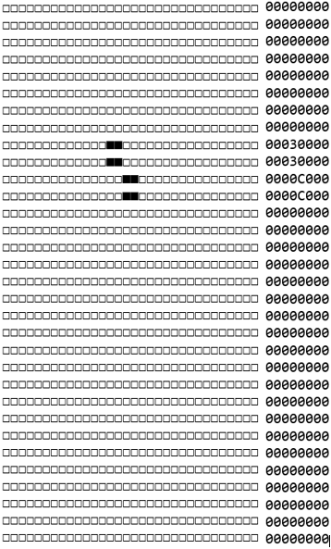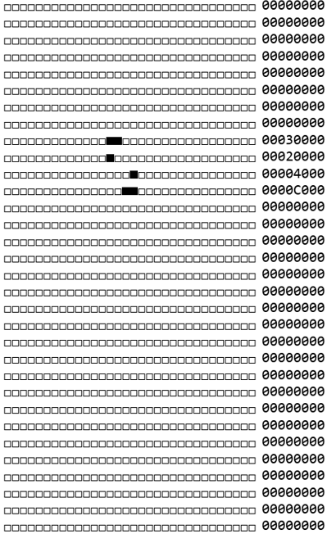

Iteration 2:
